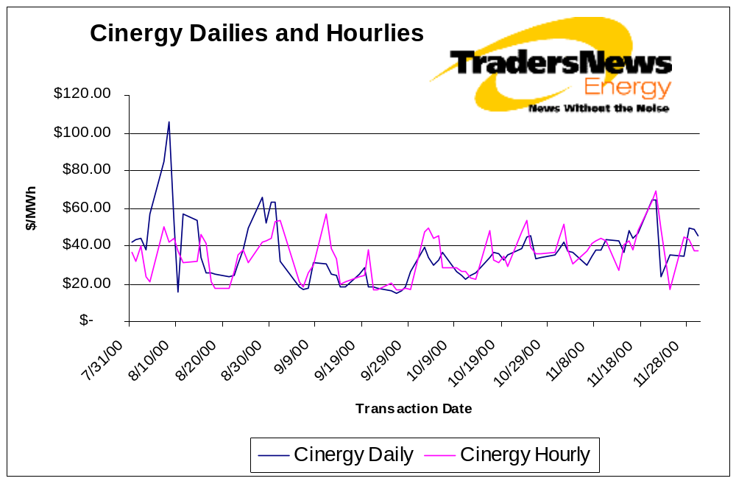

TradersNews Hourly Indexes Yield Unprecedented Hedging Strategies

TradersNews ™ Energy supplies the North American wholesale power market with
innovative hedging tools through its exclusive hourly indexes at Cinergy, Entergy and AEP.

TradersNews’ launch of the wholesale power industry’s first hourly index at the Cinergy hub Sept. 6 has received an enthusiastic response from a variety of power industry participants, including wholesale near- and short-term traders; aggregators; risk managers; analysts; quantitative analysis specialists; general counsel; lobbyists; retailers, and regulators.

Already, the Cinergy hourly index has become the benchmark for financial hourly trading and for hedging instruments such as swaps and spreads. Enron Online has been making markets off the Cinergy hourly index for several months and another online trading platform is preparing to offer financial swaps off our Cinergy and Entergy hourly indexes. There also has been direct trading off of the Cinergy and AEP hourly indexes.

The Cinergy hourly, daily and term indexes are available, along with similar indexes for AEP and Entergy, at www.tradersnewspower.com. More indexes, including TVA, ComEd and ERCOT, will be launched shortly.

In addition to financial swaps, these hourly indexes offer other opportunities for risk management:

- Hedging hourly against daily prices
- Improving liquidity
- Educating the marketplace (i.e., cost of replacement power)
- Forecasting loads
- Price discovery for retail programs
- Informing “back office” (accounting) staff
- Providing historical information
- Benchmarking for emerging pools
- Allowing comparison against pool pricing

These hourly indexes track the range and weighted average price of trading done at a given point for each on-peak hour, Monday through Friday. The weighted average index
for the day factors in the volume done for each on-peak hour that actually traded. If no trades are reported for any given hour, “indicative” pricing is provided. Indicative pricing is derived from the tightest bid/ask spread for each hour not traded.

About TradersNews ™
Designed by traders, for traders, TradersNews Energy provides real-time news and market commentary for electric power and natural gas traders. TradersNews helps these professionals make smart decisions by providing insightful analysis and news that moves the markets – filtering out the “noise” found on more general industry news wires. Based in Houston, TradersNews is a service of Internet Publishing Group, Inc.

About Internet Publishing Group
Internet Publishing Group™ (www.ipgdirect.com), founded in 1999 by five former Dow Jones executives, is a leading content-for-commerce (C4C) company serving clients in energy, commercial real estate, private equity and emerging markets. The company, based in Newtown, PA, provides pricing data, market news, expert commentary and research to business professionals and companies operating in business-to-business (B2B) markets.

Questions or feedback?
Contact Bobette Riner, at 713/ 647-8690, or email her at bobette.riner@ipgdirect.com;
Ellen Clardy, Ph.D., at 713/647-6603, or email her at ellen.clardy@ipgdirect.com, or Suzanna Strangmeier, at 713/647-7325, or email her at suzanna.strangmeier@ipgdirect.com.



